**INTRODUCTION**

**NAME :-**RASHID ALI

**BRANCH :-**BCA

**COURSE :-**BACHELOR OF COMPUTER

APPLICATIONS

**ROLL NO :-**229217

**FACULTY :-**GARVIT VERMA

**ACKNOWLEDGEMENT**

I would like to express my profound gratitude to Mrs **ANKITA ma’am**, of bachelor of computer applications department, and **Mr Lalit Kumar Sharma** of St. Andrews Institute of Technology And Management for their contributions to the completion of my project titled “KANEKI”

I would like to express my special thanks to our mentor Mr Garvit Verma for his time and efforts he provided throughout the year. Your useful advice and suggestions were really helpful to me during the project’s completion. In this aspect, I am eternally grateful to you.

I would like to acknowledge that this project was completed entirely by me and not by someone else.

RASHID ALI

**CERTIFICATE**

This is to certify that the project entitled, “KANEKI” submitted by “RASHID ALI” in partial fulfilment of the requirements for the project of creating homepage of any desired website in “BCA” at the “St. Andrews Institute Of Technology And Management” is an authentic work carried out by him under my supervision and guidance.

To the best of my knowledge, the matter embodied in the project has not been copied to any other websites or from any individual.

Date:

Given By-Mr Garvit Verma

**INDEX**

|  |  |  |
| --- | --- | --- |
| **S No.** | **Title** | **Page No.** |
| 1. | INTRODUCTION | 1 |
| 2. | Source Code | 5-9 |
| 3. | Output | 10-12 |
| 4. | Conclusion | 13 |
| 5. | Bibliography | 14 |

**SOURCE CODE**

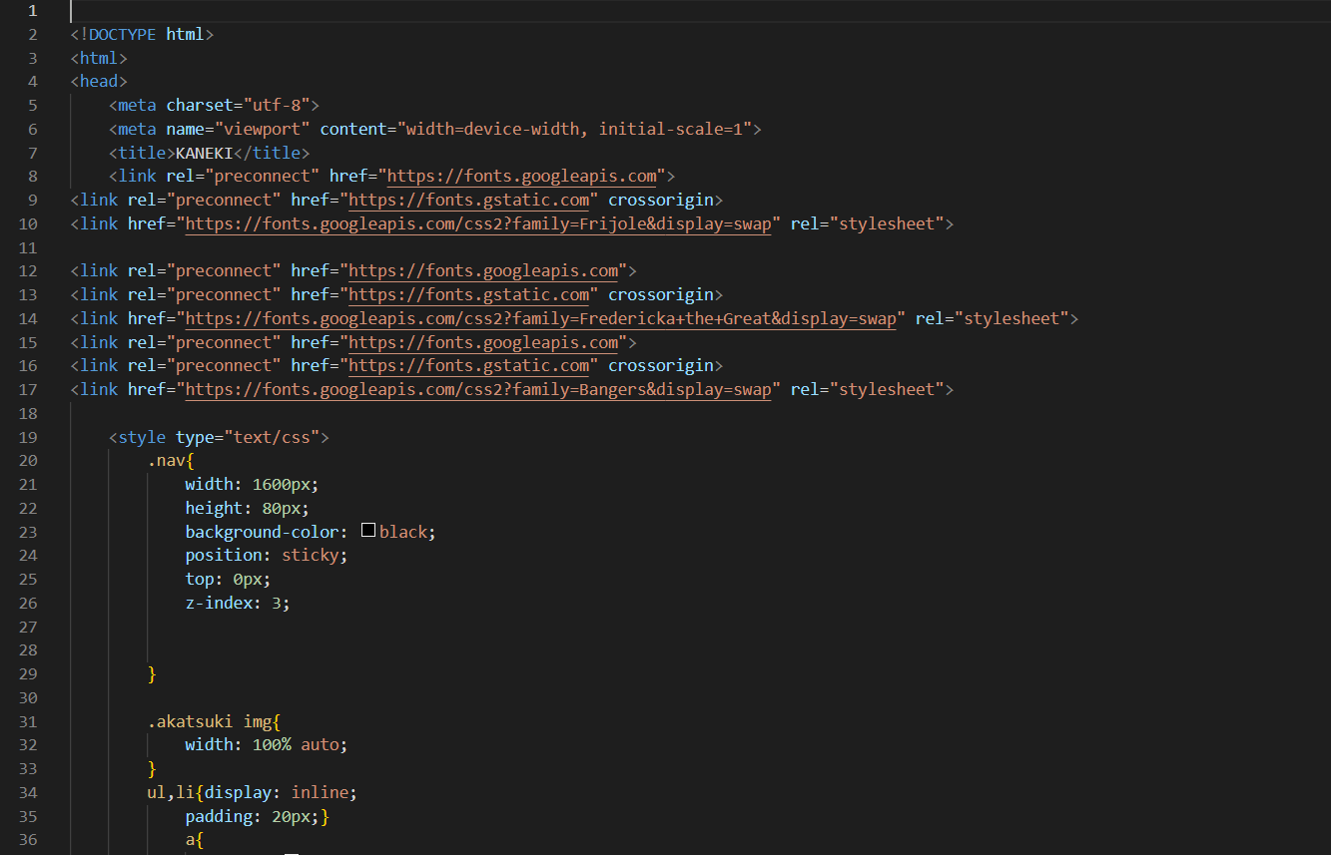

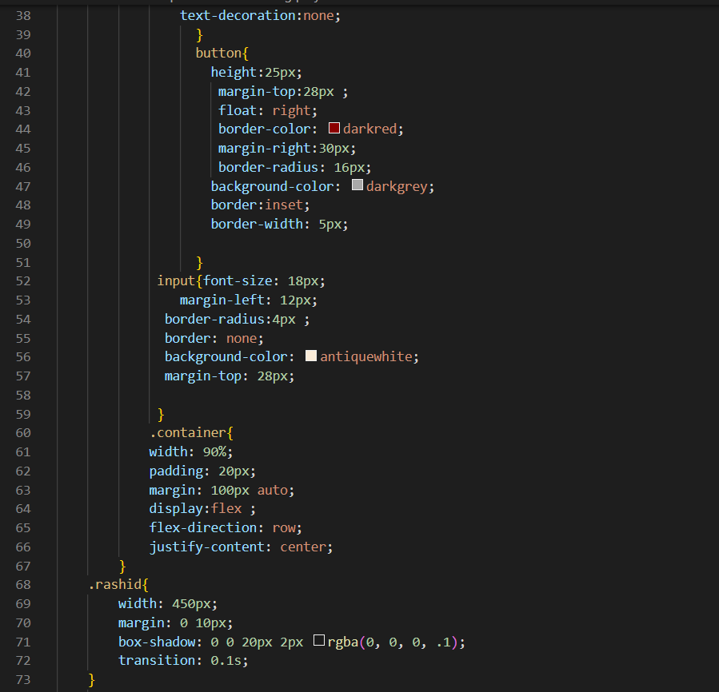

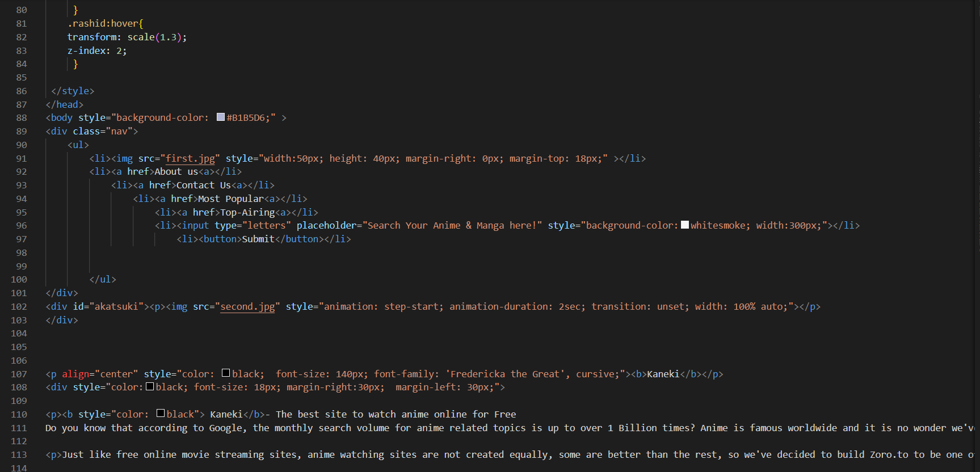

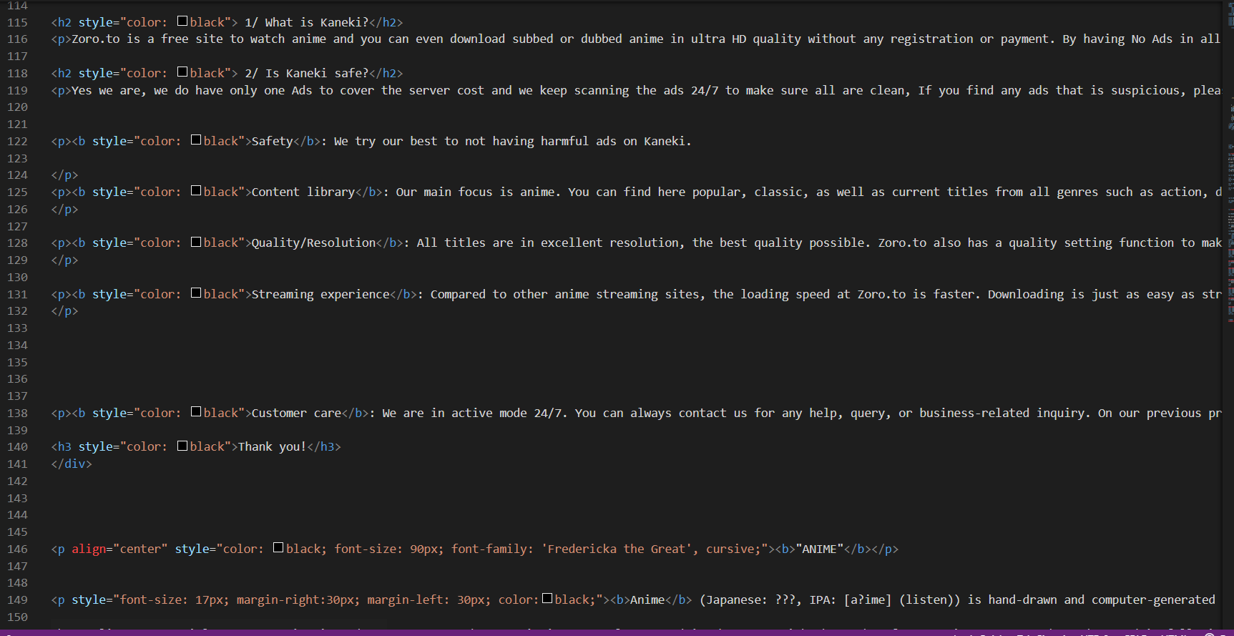

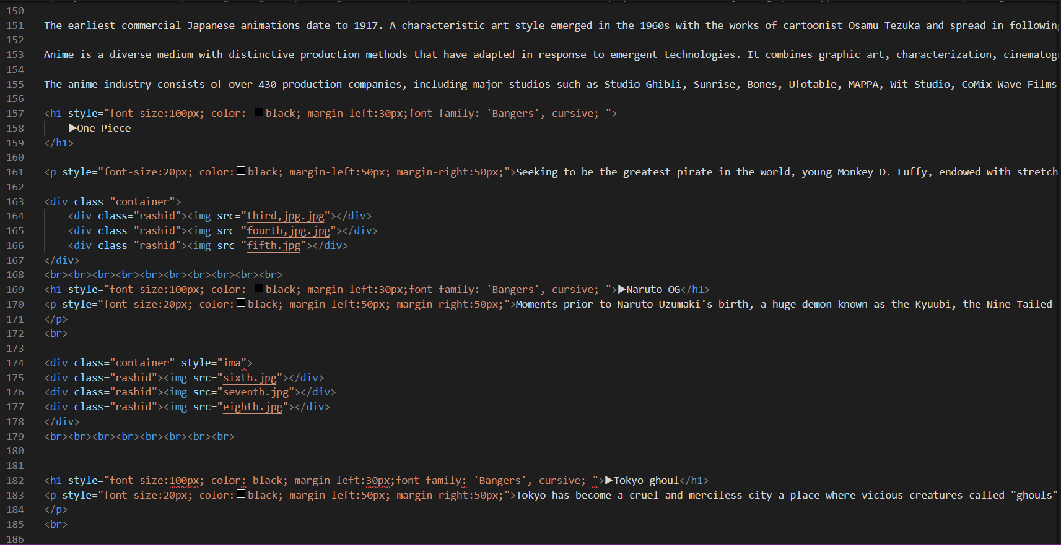

**RESULT**

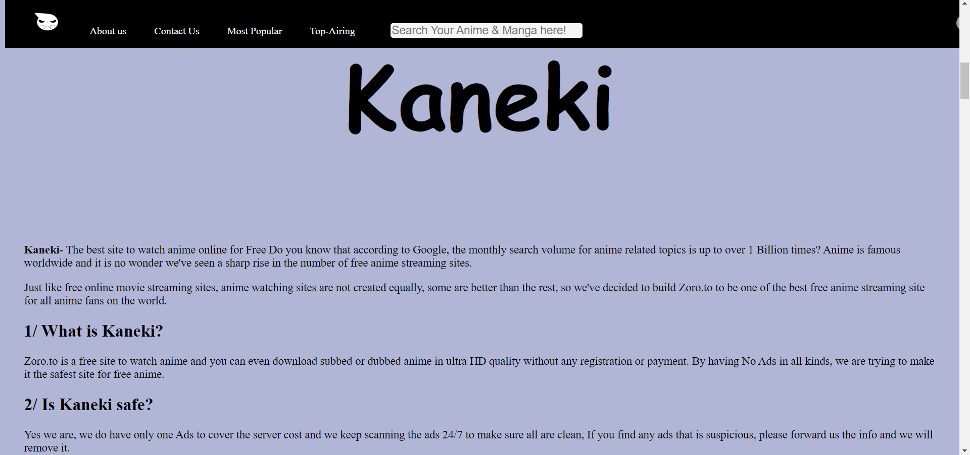

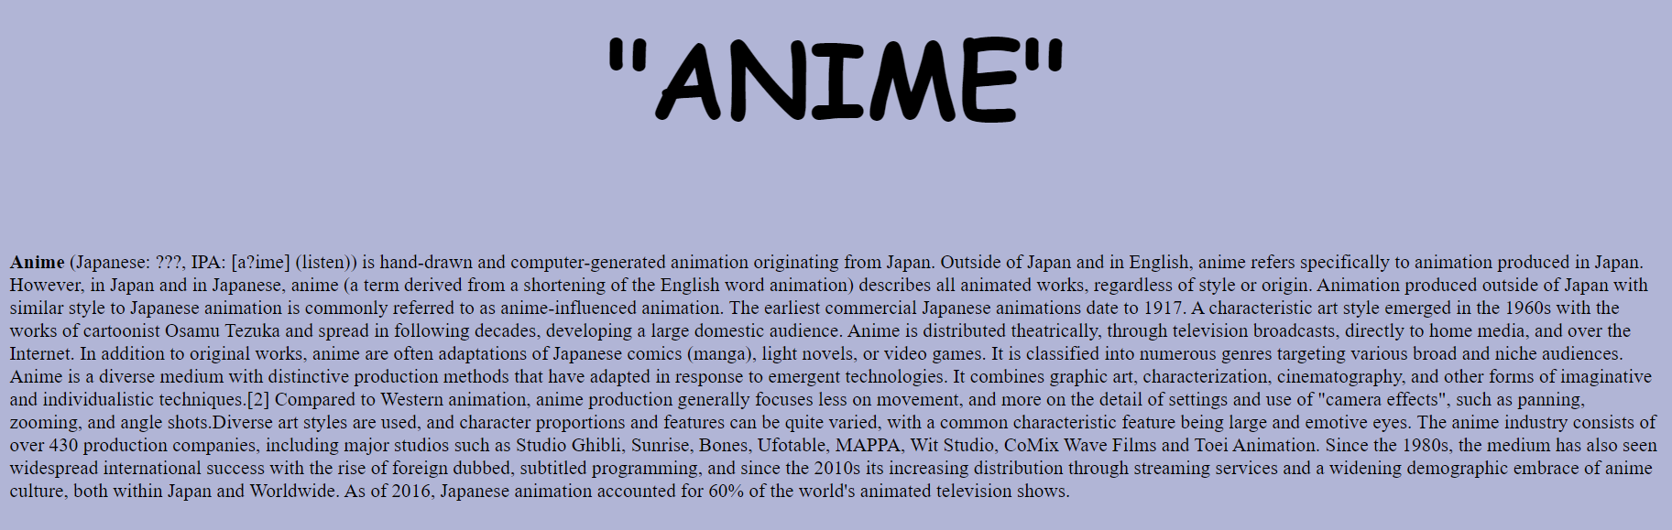

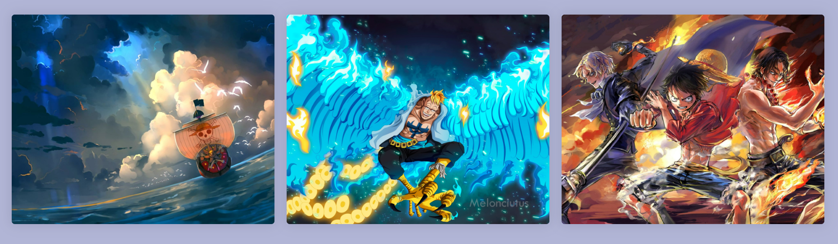

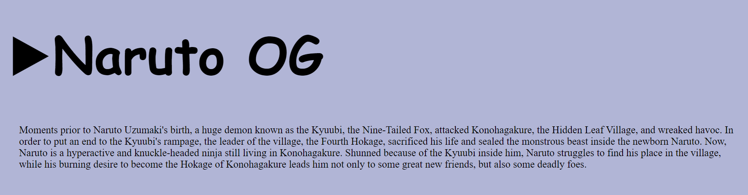

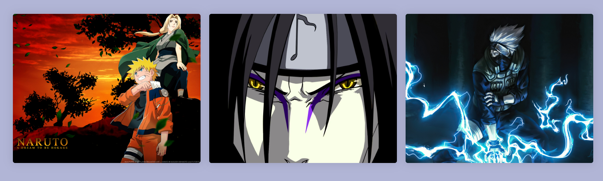

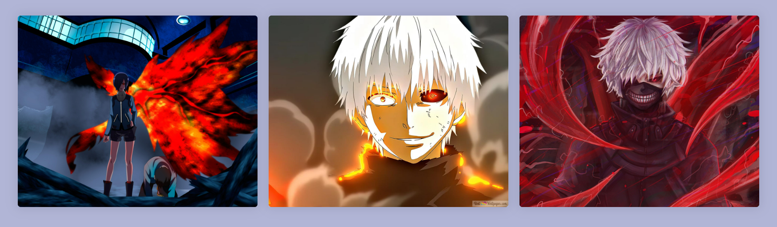

**CONCLUSION**

This Website Is created only using HTML and CSS. This Website is based on an anime website, basically it is a website to watch “Anime”. Anime is Animated series based on manga (a type of comic but created only Japan). I have included some of popular anime of all time they are Naruto, Naruto Shippuden, One Piece, Jujutsu Kaisen, Demon Slayer, Attack on Titan, Tokyo Ghoul, Tokyo Revengers, Bleach, Boruto (Naruto Next generations) and Death Note.

**BIBLIOGRAPHY**

* Help Is taken from Internet (From Various Website)
* Help is taken from YouTube also through multiple channels.
* From My own Notes
* From friends also.